**Student Automation Story**

Furkan GÖZÜKARA is a teacher who keeps his students' notes in the system and tries to make sure that his students can log in to this system and see his / her notes.

There are teacher and student entrances in the prepared automation system. When the introduction from the teacher system; Adding notes, editing, adding, annotating and editing sections are available.

In the main part of the panel, you can add courses, correct courses, delete lessons, add announcements and add students.

If he / she selects the course, he / she will register the course after determining the code, name, credit number of the course you want to add, and the percentages to be taken in the midterm and final.

If he / she selects correct course, he / she can make changes to the courses he / she added.

If he / she selects the course, he / she removes the course from the system.

If he / she selects the courses, the courses he / she added are listed.

When the students click on these courses, the students are listed in the lesson. When the teacher selects the student, the screen for entering the midterm and final grades is displayed and the student's grades are recorded.

When the student system is accessed;

Add lessons, delete lessons, can view the course notes and announcements made by the teacher.

If he / she selects the course, he / she can choose from the courses that the teacher has registered in the system.

If you select Delete course, you can delete the courses you want to delete from this screen.

If he / she chooses the grade, he / she can see the notes that he / she has taken from the courses. In this way, teachers and students can easily follow the course and follow-up.

Test status description for course note insertion

**User and System requirements**

**Examples of nonfunctional requirements**

|  |  |
| --- | --- |
| **v.1.0.3.** | **Letter Grade / Control Program/** |
| **function** | Determine lecture note FF>AA |
| **description** | Determines that the average of the course taken is between FF- and AA. |
| **input** | 0-100 numerical notes. |
| **source** | Student’s exam paper. |
| **output** | Student’s letter grade. |
| **object** | Did the student go through the class? |
| **action** | When the student takes notes below sixty points, we can see whether he has passed the course or not. If he gets over sixty points, we determine the letter grade according to his passing and the score he / she gets. |

**Scenario for controlling student information in automation**

**SYSTEM SCHEMA**

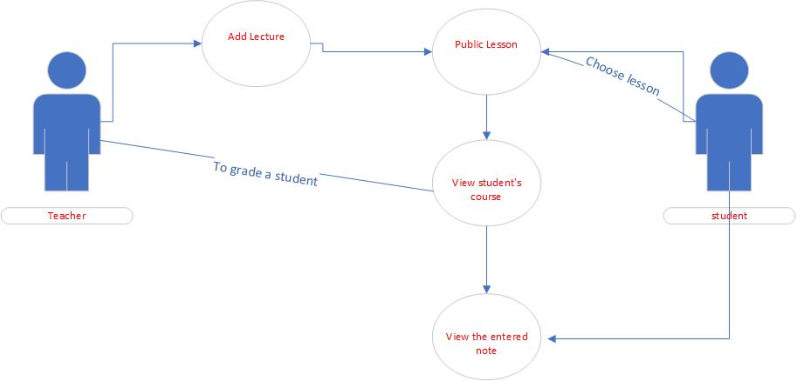

**Automation Contexts**

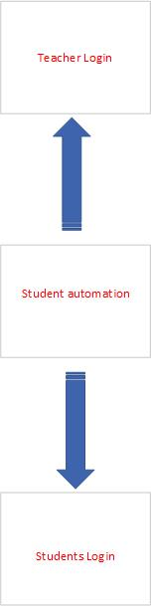

**SYSTEM OPERATİON**

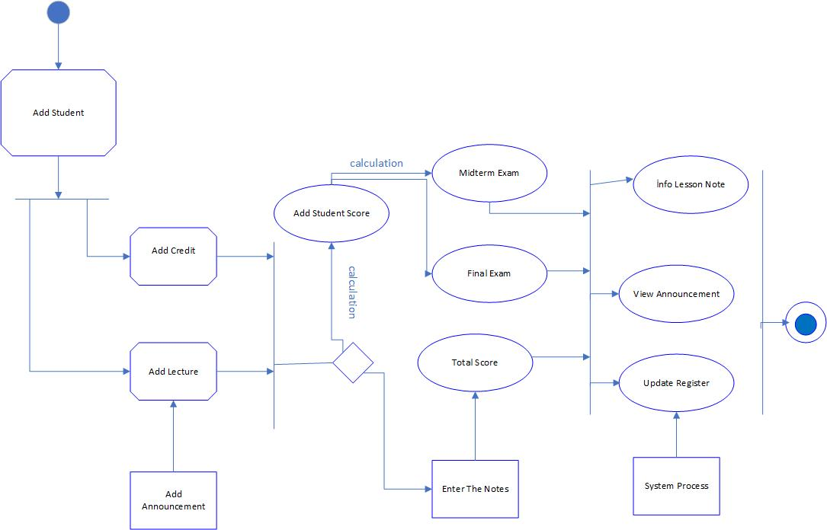

**Transfer data usage status**

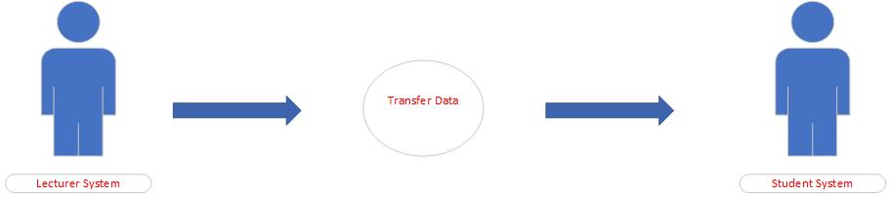

**DESCRİPTİON TABLE**

|  |  |
| --- | --- |
| **Transfer data** | **Table description of student information status** |
| **Actions** | Student Automation System |
| **Explanation** | Teacher can add courses in Automation. The teacher can enter the student's lecture notes.  The student can add or delete lessons from this screen. |
| **Data** | Student information |
| **Comments** | The teacher must have appropriate security permissions to access student information. |

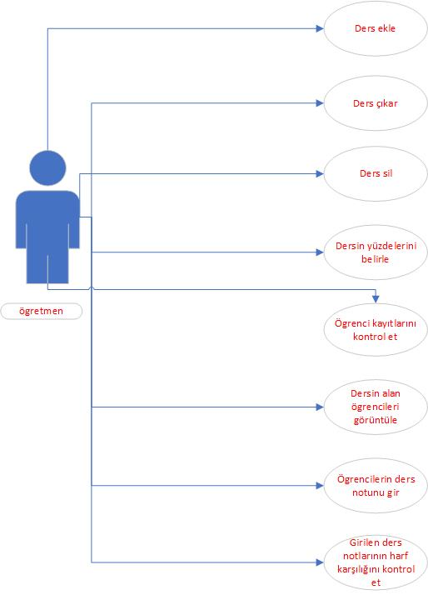**Lecturer on System Roles**

**İnput Diagram for Automation**

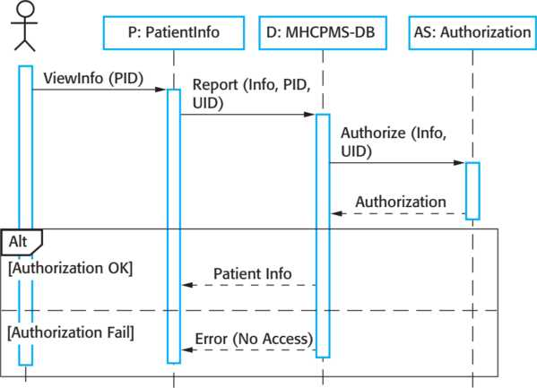

**Array Diagram for Student Data**

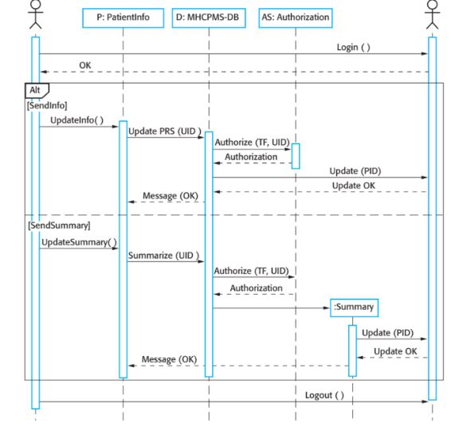

**Classes and association**

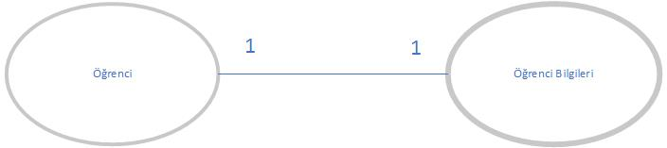

**REQUİREMENTS**

**SYSTEM ACTİONS**

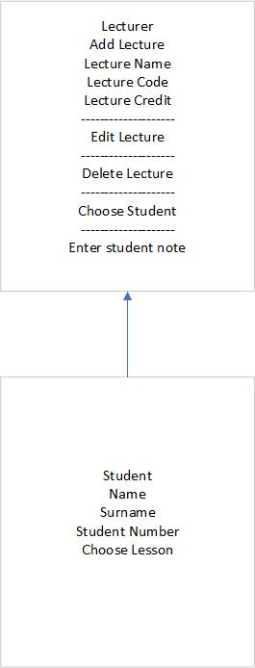

**SYSTEM OUTPUT INPUT**

